Title

FIRST AUTHOR¹ (e.g. S. BOTTICELLI¹), OTHER AUTHORS²

¹ Affiliation, Address, City
² Affiliation, Address, City
e‐mail first author
(please leave
2 blank lines and delete this text)
Authors are kindly asked to use ONLY this MS Word template to submit a one-page abstract in a single-column format. The maximum length of the abstract is one-page (including references) following strictly this template (fonts, spacing, etc).
Figures and tables can be embedded in this section. Caption should be given below the figures and above the tables. Ensure that figures have a sufficient resolution. Since the abstract will be shared electronically, the use of colours for pictures is allowed.
The file must be saved in the format MS Office Word (docx, NOT pdf).

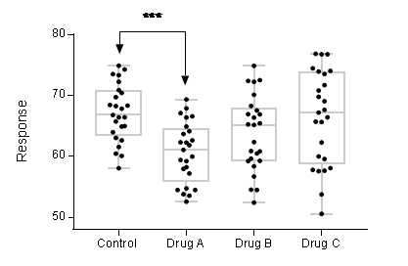

Figure 1. Description

References:
[1] Y. Sun, X. Fan, Anal. Bioanal. Chem., 399, 205-211 (2011).
[2]
[3]

