**Title**

FIRST AUTHOR1 (e.g. C. CAMPI1), OTHER AUTHORS2

*1 Affiliation, Address, City*

*2 Affiliation, Address, City*

e‐mail first author

(please leave

2 blank lines and delete this text)

Authors are kindly asked to use ONLY this MS Word template to submit a one-page abstract in a single-column format. The maximum length of the abstract is one-page (including references) **following strictly this template** (fonts, spacing, etc).

Figures and tables can be embedded in this section. Caption should be given below the figures and above the tables. Ensure that figures have a sufficient resolution. Since the abstract will be shared electronically, the use of colours for pictures is allowed.

The file must be saved in the format MS Office Word (doc, docx, **NOT pdf**).

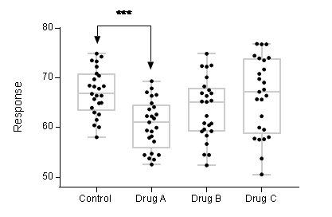

**Figure 1**. Description

**References:**

[1] Y. Sun, X. Fan, *Anal. Bioanal. Chem.*, 399, 205-211 (2011).

[2]

[3]